Respond to the following statements for each one of the articles that follow. You should choose:

Disagree strongly disagree agree agree strongly

1. I understand the article.
2. I think that the information is reliable.
3. I think that this information represents the situation fairly.
4. I find this information alarming.

Respond to these statements after reading all the articles:

1. Most of the Australian population can make an informed decision about the actions of these bodies.
2. The world must substantially increase the percentage of energy generated from nuclear fission.
3. We must accept the risks of nuclear accidents as part of our commitment to reduce global warming.
4. Australia should support the increasing use of nuclear fission for energy by selling its uranium more freely.

**Appendix: Articles for Values Exchange exercise:**

# Article #1 World Nuclear Association [ <http://www.world-nuclear.org/info/inf01.html> accessed 13.2.2012]

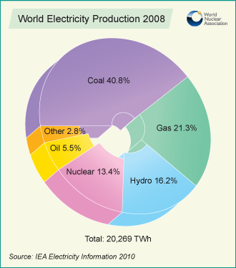

Today, only eight countries are known to have a nuclear weapons capability. By contrast, 56 operate civil research reactors, and 30 host some 440 commercial nuclear power reactors with a total installed capacity of over 377,000 MWe (see table). This is more than three times the total generating capacity of France or Germany from all sources. Over 60 further nuclear power reactors are under construction, equivalent to 17% of existing capacity, while over 150 are firmly planned, equivalent to 46% of present capacity.

In addition to commercial nuclear power plants, there are about 250 research reactors operating, in 56 countries, with more under construction. These have many uses including research and the production of medical and industrial isotopes, as well as for training.

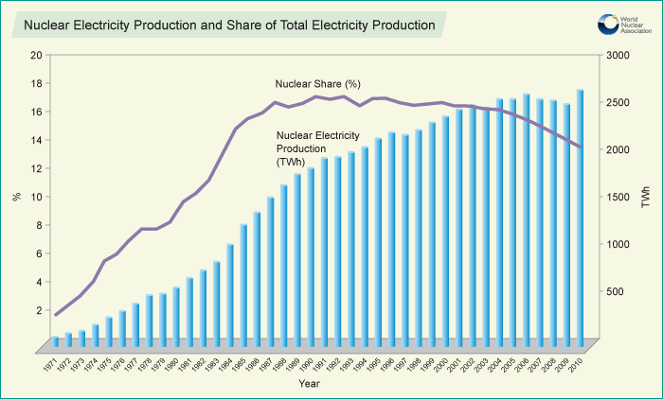

**Article #2 J**apan radiation higher than estimated October 28, 2011 SMH (Author unknown)

Source: <http://www.smh.com.au/environment/japan-radiation-higher-than-estimated-20111028-1mnld.html#ixzz1jDQojRR4>

The Fukushima nuclear disaster released twice as much of a radioactive substance into the atmosphere as Japanese authorities estimated, reaching 40 per cent of the total from Chernobyl, a preliminary report says.

The estimate of much higher levels of radioactive cesium-137 comes from a worldwide network of sensors. Study author Andreas Stohl of the Norwegian Institute for Air Research says the Japanese government estimate came only from data in Japan, and that would have missed emissions blown out to sea.

The study did not consider health implications of the radiation. Cesium-137 is dangerous because it can last for decades in the environment, releasing cancer-causing radiation.

The long-term effects of the nuclear accident are unclear because of the difficulty of measuring radiation amounts people received.

In a telephone interview, Stohl said emission estimates are so imprecise that finding twice the amount of cesium isn't considered a major difference. He said some previous estimates had been higher than his.

The journal *Atmospheric Chemistry and Physics* posted the report online yesterday for comment, but the study has not yet completed a formal review by experts in the field or been accepted for publication.

Last summer, the Japanese government estimated that the March 11 Fukushima accident released 15,000 terabecquerels of cesium. Terabecquerels are a radiation measurement. The new report from Stohl and co-authors estimates about 36,000 terabecquerels through April 20. That's about 42 per cent of the estimated release from Chernobyl, the report says.

The Nuclear and Industrial Safety Agency, the Japanese government branch overseeing such findings, was not immediately available for comment.

It also says about a fifth of the cesium fell on land in Japan, while most of the rest fell into the Pacific Ocean. Only about 2 per cent of the fallout came down on land outside Japan, the report concluded.

Experts have no firm projections about how many cancers could result because they are still trying to find out what doses people received. Some radiation from the accident has also been detected in Tokyo and in the United States, but experts say they expect no significant health consequences there.

Still, concern about radiation is strong in Japan. Many parents of small children in Tokyo worry about the discovery of radiation hotspots even though government officials say they do not pose a health risk.

And former prime minister Naoto Kan has said the most contaminated areas inside the evacuation zone could be uninhabitable for decades.

**Article #3 Miners soar on India uranium move Peter Kerr (SMH** *November 15, 2011*)

Source: <http://www.smh.com.au/business/miners-soar-on-india-uranium-move-20111115-1ng51.html#ixzz1jDLMyvhV>

Australian uranium miners have welcomed a move by Prime Minister Julia Gillard to allow sales of the controversial nuclear fuel to India, which sent shares in the sector soaring.

Ms Gillard has revealed she will lobby her colleagues in the ruling Australian Labor Party to change their internal policy on uranium, which currently prevents sales to India despite allowing sales to many other nations, including China.

Her support for the change is likely to result in the ALP changing the policy, despite internal opposition expected to come from members of the party's left faction.  
  
Indian companies already pump significant amounts of money into Australian coal projects, and Mr Hall said the ability for Indian companies to buy Australian uranium would likely see many Indian companies try to strike offtake and investment deals with local miners.

Mr Hall said last Friday's sudden jump in global uranium prices - where the price rose by just short of ten per cent - was a more significant symbolic development for the industry than Ms Gillard's support for sales to India.

But environmental groups have expressed concerns at Ms Gillard's push, with the Australian Conservation Foundation urging the Labor Party to keep the export ban in place so long as India was not a signatory to the nuclear non-proliferation treaty.

“The Labor Party has a long-standing, prudent and sensible policy of not supplying uranium to countries that will not sign the international nuclear non-proliferation treaty,” said ACF nuclear free campaigner Dave Sweeney.

“The non-proliferation treaty, while imperfect, remains a key international legal mechanism in restricting the spread of nuclear weapons technology.

"Uranium is a dual-use fuel – it can be used in reactors and it can be used to power the world's worst weapons."

Uranium miners have suffered a dreadful year, with investor confidence evaporating in the wake of the Japanese nuclear incident in March.

The Japanese incident lead to plummeting share prices for uranium miners, which was compounded by falls in the uranium price.

But uranium miners insist the long-term demand for uranium has barely changed in the wake of the disaster, with the majority of the nations using nuclear power - excluding Germany - retaining their plans to increase their use of nuclear power.

Another miner, ERA, did not comment.

BHP Billiton is one company that could benefit significantly if uranium sales to India become legal, given the company's plan to develop the world's biggest uranium mine at Olympic Dam in South Australia.

BHP does not currently sell uranium to India, but said it may review that position if the Australian Government were to change policy and appropriate safeguards were in place.